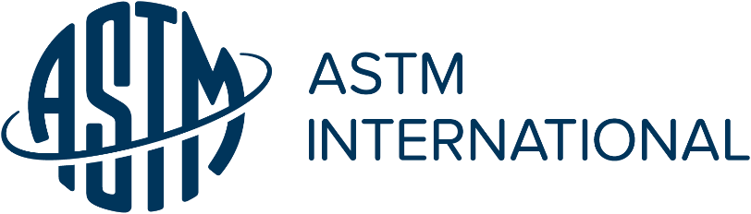
THE MARY R. NORTON MEMORIAL SCHOLARSHIP AWARD FOR WOMEN

Administered by

ASTM International Committee E04 on Metallography

PURPOSE: ASTM Technical Committee E04 sponsors the Mary R. Norton Memorial Scholarship to encourage women undergraduate seniors or first-year graduate students to pursue the study of Physical Metallurgy or Materials Science with emphasis on the relationship of microstructure to material properties.

ELIGIBILITY: Applicants must be registered full-time students and classified as an undergraduate senior or first-year graduate student during that specific academic year.

SELECTION CRITERIA: The winner will be chosen based on her interest or potential interest in a career in Physical Metallurgy or Materials Science as evidenced by her application statements and faculty recommendation.

AWARD: The award, in the amount of $1,000.00 (USD), is intended to be used for educational expenses during the current academic year. Selection and notification of the winner will be sent to the student and school by January 31st.

AWARD SPONSORS: The following companies recognized the value of women in engineering and have provided financial support for the continuation of this scholarship: Allvac, Chaparral Steel, Buehler Ltd., Struers, Clemex, Definitive Imaging, Ford Motor Company, Wyman Gordon Foundation, Nikon, Crown Cork & Seal, Cummins Engine Company, ASM-Carolina Southern Piedmont Chapter and ASM-South Central PA Chapter.

SUBMISSION: Completed applications shall be submitted electronically to the E04 Awards and Honors Chairperson

Janet Gbur
Case Western Reserve University
jlg120@case.edu

APPLICATIONS DUE DECEMBER 15

MORE INFO: For general inquiries about this award or Committee E04, please contact ASTM Staff Manager, Travis Murdock (tmurdock@astm.org)

ASTM Committee E04 MARY R. NORTON MEMORIAL SCHOLARSHIP

STUDENT APPLICATION

Name

Address

Phone Number

E-Mail Address DOB

University in which enrolled

Major & Minor Expected date of graduation

Currently enrolled as (select one): Undergraduate Senior First-year Graduate

Grade Point Average for two (2) preceding years for related Metallurgy or Materials Science Courses (include Math, Physics, Metallurgy, Chemistry, Materials Science & Engineering)

GPA Total Achievable GPA

Attachments: The applicant must attach the following for consideration: (1) an essay (one-page 12-point typed) reflecting your interest in, and any experience or accomplishments toward, a career in physical metallurgy or materials science; (2) a listing of any honors you have received; (3) an academic transcript showing grades for the two preceding academic years; (4) a faculty recommendation letter completed by the person identified below.

Faculty Reference: Please attach separately a faculty recommendation

Faculty Reference Name

Address

Phone Number

E-Mail Address

I CERTIFY THAT I HAVE PROVIDED ACCURATE INFORMATION AND THAT I WILL USE THE SCHOLARSHIP TO HELP MEET MY EDUCATIONAL EXPENSES DURING THE ACADEMIC YEAR

Applicant Signature Date

Faculty Reference Signature Date

APPLICATIONS DUE DECEMBER 15

